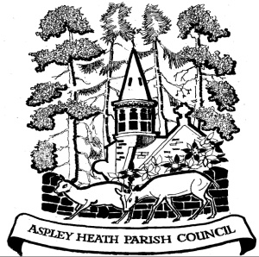
ASPLEY HEATH PARISH COUNCIL

Clerk: Denise Batchelor
Tel: 01525 717905
Email:clerk@aspleyheath.org.uk

AGENDA

ASPLEY HEATH ANNUAL PARISH MEETING

The Annual Assembly of the Parish Meeting for Aspley Heath will be held at the Methodist Church, High Street, Woburn Sands on Wednesday 27th April 2022 at 8.00pm.

The business to be transacted at the Meeting will be as follows:-

- Minutes of the previous Annual Meeting – Weds 28th April 2021

- Matters Arising

- To receive information from Mr P Ballard on the Poor’s Coal Charity

- Report from Central Bedfordshire Councillor; John Baker

- Report from the Chairman Sally Smith covering the activities of the Parish

- Update on the work of the Neighbourhood Plan Steering Group; Chair, Gill Clough

- Accounts for year ending 31 March 2022 (unaudited)

- Planning Report from Planning Sub-Committee to include

- South East Milton Keynes Strategic Urban Extension (SEMK)
- East West Rail consultation – including Woburn Sands crossing proposals
- Marston Vale Development Plan for 5000 new houses in Marston Moretaine

- Questions

................................
Chairman Date: 20/4/2022

